**SECTION A-46 MARKS**

**Attempt** all **questions in this section.**

1. **The standard electrode potentials for some half-cell reactions are given below.**

**Cl-(aq)** **½Cl2(g) + e Eϴ = -1.36V**

**Mn2+(aq) + 2H2O(l)** **MnO2(g) + 4H+(aq) + 2e Eϴ = -1.53V**

1. **Write the:**
2. **Cell notation for the cell formed when the two half cells are combined. (01 mark)**

**………………………………………………………………………………………………………………………………………………………………………………………………………………………………………………**

1. **Equation for the overall cell reaction. (01½ marks)**

**………………………………………………………………………………………………………………………………………………………………………………………………………………………………………………**

1. **Calculate the e.m.f of the cell in a (i) above. (01½ marks)**

**……………………………………………………………………………………………………………………………………………………………………………………………………………………………………………..**

**………………………………………………………………………………………………………………………**

1. **State whether the cell reaction is feasible or not. Give a reason for your answer. (01 mark)**

**……………………………………………………………………………………………………………………..**

**……………………………………………………………………………………………………………………………………………………………………………………………………………………………………………….**

1. **Define the term electrolytic conductivity. (01 mark)**

**…………………………………………………………………………………………………………………………………………………………………………………………………………………………………………………………**

1. **The electrolytic conductivity of a 0.0634 molar solution of a weak acid HA at 25ᵒC is 1.138 x 10-3s/cm and its molar conductivity at infinite dilution is 388.5scm2/mol.calculate the:**
2. **Degree of ionization of HA. (02 marks)**

**………………………………………………………………………………………………………………………………………………………………………………………………………………………………………………………………………………………………………………………………………………………………………………………………………………………………………………………………………………………………………………….**

**……………………………………………………………………………………………………………………………………………………………………………………………………………………………………………………….**

1. **Acid dissociation constant, Ka at 25ᵒC. (01½ marks)**

**………………………………………………………………………………………………………………………………………………………………………………………………………………………………………………………………………………………………………………………………………………………………………………………………………………………………………………………………………………………………………………….**

**……………………………………………………………………………………………………………………………………………………………………………………………………………………………………………………….**

1. **An organic compound, Z has the structure as shown below.**



1. **Name the functional groups in the structure of organic compound, Z. (01 mark)**

**……………………………………………………………………………………………………………………………………………………………………………………………………………………………………**

1. **State what is observed and write equation for the reaction in each case that takes place when organic compound, Z is:**
2. **Treated with cold aqueous alkaline solution of potassium manganate (VII) ions. (02 marks)**

**Observation(s):**

**……………………………………………………………………………………………………………………………………………………………………………………………………………………………………**

**Equation:**

**…………………………………………………………………………………………………………………………………………………………………………………………………………………………………..**

1. **Added to aqueous sodium hydrogen carbonate solution. (01½ marks)**

**Observation(s):**

**……………………………………………………………………………………………………………………………………………………………………………………………………………………………………**

**Equation:**

**…………………………………………………………………………………………………………………………………………………………………………………………………………………………………..**

1. **Explain what is meant by the term first electron affinity? (01 mark)**

**…………………………………………………………………………………………………………………………………………………………………………………………………………………………………………………………………………………………………………………………………………………………………………………………………………………………………………………………………………………………….**

1. **Write an equation to represent the first electron affinity of sulphur. (01 mark)**

**………………………………………………………………………………………………………………………………………………………………………………………………………………………………………………**

1. **Explain why the value for the first electron affinity of sulphur is negative whereas the value for the second electron affinity is positive. (03 marks)**

**………………………………………………………………………………………………………………………………………………………………………………………………………………………………………………………………………………………………………………………………………………………………………………………………………………………………………………………………………………………………………………………………………………………………………………………………………………………………………………………………………………………………………………………………………………**

1. **Write equation for the reaction between chlorine and:**
2. **Cold dilute sodium hydroxide solution. (01½ marks)**

**…………………………………………………………………………………………………………………………………………………………………………………………………………………………………………………………**

1. **Potassium iodide solution. (01½ marks)**

**…………………………………………………………………………………………………………………………………………………………………………………………………………………………………………………………**

1. **State what:**
2. **Would happen if the resultant mixture in a (i) was heated. (01½ marks)**

**…………………………………………………………………………………………………………………………………………………………………………………………………………………………………………………………………………………………………………………………………………………………………………………………………………………………………………………………………………**

1. **Happened in a (ii). (01 mark)**

**…………………………………………………………………………………………………………………………………………………………………………………………………………………………………………………………**

1. **Complete the following equations and in each case, outline the mechanism for the reaction.**
2. **CH3CH2OH**  **(03 marks)**

**…………………………………………………………………………………………………………………………………………………………………………………………………………………………………………………………………………………………………………………………………………………………………….**

**…………………………………………………………………………………………………………………………………………………………………………………………………………………………………………………………………………………………………………………………………………………………………….**

 **(03 marks)**

**…………………………………………………………………………………………………………………………………………………………………………………………………………………………………………………………………………………………………………………………………………………………………….**

**…………………………………………………………………………………………………………………………………………………………………………………………………………………………………………………………………………………………………………………………………………………………………….**

1. **Nylon-6,6 is formed by the reaction between hexane-1,6-diamine and hexane-1,6-dioic acid.**
2. **Write equation for the formation of Nylon-6,6. (01½ marks)**

**………………………………………………………………………………………………………………..**

**……………………………………………………………………………………………………………………………………………………………………………………………………………………………………………………………………………………………………………………………………………………**

1. **State the type of polymerization involved in the formation of Nylon-6,6. (0½ mark)**

**……………………………………………………………………………………………………………**

1. **The osmotic pressure of a solution containing 2g/dm3 of Nylon-6,6 at 25ᵒC was 202.8Nm-2**
2. **Calculate the relative molecular mass of Nylon-6,6. (02 marks)**

**…………………………………………………………………………………………………………………………………………………………………………………………………………………………………………………………………………………………………………………………………………………………………………………………………………………………………………………………………………………………………………………………………………………………………………………………………………………………………………………………………………………………………………………………………………………………………………………………………………………………………………………………………………………………………………………………………………………..**

1. **State one use of Nylon-6,6. (0½ mark)**

**………………………………………………………………………………………………………………………………………………………………………………………………………………………………………………**

1. **Write equation for the dissolution of each of the following salts in water. State whether the resultant solution is neutral, basic or acidic.**
2. **Potassium chloride. (02 marks)**

**…………………………………………………………………………………………………………………………………………………………………………………………………………………………………………………………………………………………………………………………………………………………………………………………………………………………………………………………………………………………………………………..**

1. **Aluminium chloride. (02 marks)**

**……………………………………………………………………………………………………………………………………………………………………………………………………………………………………………………………………………………………………………………………………………………………………………………………………………………………………………………………………………………………………………………**

1. **Sodium propanoate. (02 marks)**

**………………………………………………………………………………………………………………………………………………………………………………………………………………………………………………………………………………………………………………………………………………………………………………………………………………………………………………………………………………………………………………….**

1. **Various concentrations of A and B were reacted at a constant temperature. The table below shows the initial concentrations of A and B with their initial rates for the reaction.**

|  |  |  |  |
| --- | --- | --- | --- |
| **experiments** | **[A] (mol/dm3)** | **[B] (mol/dm3)** | **Initial rate (mol/dm3/s** |
| **1** | **0.4** | **0.4** | **7.00 x 10-4** |
| **2** | **0.8** | **0.8** | **2.80 x 10-3** |
| **3** | **1.6** | **0.8** | **1.12 x 10-2** |

1. **State the order of reaction with respect to A and B. (01 mark)**

**……………………………………………………………………………………………………………………………………………………………………………………………………………………………………………..**

1. **Give a reason for your answer in (a) above. (02 marks)**

**………………………………………………………………………………………………………………………**

**………………………………………………………………………………………………………………………………………………………………………………………………………………………………………………………………………………………………………………………………………………………………………………………………………………………………………………………………………………………………………………………………………………………………………………………………………………………………………………………………………………………………………………………………………………**

1. **Determine the overall order of the reaction. (01 mark)**

**……………………………………………………………………………………………………………………………………………………………………………………………………………………………………………..**

**………………………………………………………………………………………………………………………………………………………………………………………………………………………………………………**

**SECTION B-54 MARKS**

**Attempt** ANy **six questions in this section.**

1. **Two isomeric compounds A & B of molecular formula C3H8O can be oxidized to C & D respectively. C reacts with Fehling’s solution to produce a red precipitate E.D has no action with Fehling’s solution but it gives a white crystalline product when reacted with a saturated solution of sodium hydrogen sulphite just like C.**
2. **Identify the compounds A, B, C, and D & E. (02½ marks)**

**A: …………………………………………………………………………………………………………….**

**B: …………………………………………………………………………………………………………….**

**C: …………………………………………………………………………………………………………….**

**D: …………………………………………………………………………………………………………….**

**E: …………………………………………………………………………………………………………….**

1. **Write equation for the reaction that takes place when the following compounds react with each other and name the main product.**
2. **C and hydroxylamine. (01 mark)**

**………………………………………………………………………………………………………………………………………………………………………………………………………………………………………………………………………………………………………………………………………………………………**

1. **B and phosphorus (V) chloride. (01 mark)**

**…………………………………………………………………………………………………………………………………………………………………………………………………………………………………………………………………………………………………………………………………………………………….**

1. **C and acidified potassium dichromate solution. (01½ marks)**

**…………………………………………………………………………………………………………………………………………………………………………………………………………………………………………………………………………………………………………………………………………………………….**

1. **Product formed in b (ii) is heated with potassium hydroxide solution and ethanol. (01½ marks)**

**…………………………………………………………………………………………………………………………………………………………………………………………………………………………………………………………………………………………………………………………………………………………….**

1. **Show how bromobenzene can be converted to ethoxybenzene. (01½ marks)**

**………………………………………………………………………………………………………………………………………………………………………………………………………………………………………………………………………………………………………………………………………………………**

1. **When ammonium dichromate was heated, a green solid, R was formed. Write equation for the reaction that took place. (01½ marks)**

**…………………………………………………………………………………………………………………………………………………………………………………………………………………………………………**

1. **Green solid, R was heated with potassium hydroxide in contact with air.**
2. **State what was observed. (01 mark)**

**…………………………………………………………………………………………………………………………………………………………………………………………………………………………………………**

1. **Write the equation for the reaction that took place. (01½ marks)**

**…………………………………………………………………………………………………………………………………………………………………………………………………………………………………………**

1. **The compound formed in (b) above, when treated with water gave a yellow solution. The yellow solution turned orange when acidified with dilute sulphuric acid. Identify.**
2. **The ion that gives the yellow solution its colour. (0½ mark)**

**…………………………………………………………………………………………………………………………………………………………………………………………………………………………………………**

1. **The ion that gives the orange solution its colour. (0½ mark)**

**………………………………………………………………………………………………………………………………………………………………………………………………………………………………………..**

1. **Write ionic equation for the reaction leading to the formation of the orange colour. (01½ marks)**

**…………………………………………………………………………………………………………………………………………………………………………………………………………………………………………**

1. **The resultant solution in c (iii) above was added to excess sodium hydroxide solution.**
2. **State what was observed. (01 mark)**

**……………………………………………………………………………………………………………………………………………………………………………………………………………………………………**

1. **Write equation for the reaction that took place. (01½ marks)**

**……………………………………………………………………………………………………………………………………………………………………………………………………………………………………**

1. **Nitric acid and water are miscible in all proportions. They form a constant boiling point mixture having a boiling point 121ᵒC, composition 68% by mass of Nitric acid and density 1.42g/cm3.**
2. **Define the term constant boiling point mixture. (01 mark)**

**…………………………………………………………………………………………………………………………………………………………………………………………………………………………………………………………………………………………………………………………………………………………………………………………………………………………………………………………………………………………………………………..**

1. **Sketch a labelled diagram of the boiling point-composition for Nitric acid and water system. The boiling point of water and Nitric acid are 100ᵒC and 83ᵒC respectively. (03 marks)**

**………………………………………………………………………………………………………………………………………………………………………………………………………………………………………………………………………………………………………………………………………………………………………………………………………………………………………………………………………………………………………………………………………………………………………………………………………………………………………………..**

**………………………………………………………………………………………………………………………………………………………………………………………………………………………………………………………………………………………………………………………………………………………………………………………**

**………………………………………………………………………………………………………………………………………………………………………………………………………………………………………………………………………………………………………………………………………………………………………………………**

**(b) Describe what would happen when 20% Nitric acid is fractionally distilled. (02 marks)**

**……………………………………………………………………………………………………………………………………………………………………………………………………………………………………………………………………………………………………………………………………………………………………………………………………………………………………………………………………………………………………………………………………………………………………………………………………………………………………………………………………………………………………………………………………………………………………………..**

1. **Explain why Nitric acid and water form a constant boiling point mixture. (01 mark)**

**……………………………………………………………………………………………………………………………………………………………………………………………………………………………………………………………………………………………………………………………………………………………………………………………………………………………………………………………………………………………………………………………………………………………………………………………………………………**

1. **Calculate the molarity of the boiling point mixture. (02 marks)**

**……………………………………………………………………………………………………………………………………………………………………………………………………………………………………………………………………………………………………………………………………………………………………………………………………………………………………………………………………………………………………………………………………………………………………………………………………………………**

1. **0.0291g of compound, P containing carbon, hydrogen and oxygen gave 0.0581g of carbon dioxide gas and 0.0239g of water on complete combustion.**
2. **Calculate the empirical formula of compound, P. (03 marks)**

**………………………………………………………………………………………………………………………………………………………………………………………………………………………………………………………………………………………………………………………………………………………………………………………………………………………………………………………………………………………………**

**…………………………………………………………………………………………………………………………………………………………………………………………………………………………………………………………………………………………………………………………………………………………………………………………………………………………………………………………………………………………………………………………………………………………………………………………………………………….**

1. **When 0.14g of compound, P was vapourized at a temperature of 20ᵒC and pressure of 740mmHg, it occupied a volume of 39.5cm3.**
2. **Determine the molecular formula of compound, P. (02 marks)**

**…………………………………………………………………………………………………………………………………………………………………………………………………………………………………………………………………………………………………………………………………………………………………….**

**………………………………………………………………………………………………………………………**

**………………………………………………………………………………………………………………………**

1. **Compound, P reacted with sodium hydrogen carbonate with effervescence. Write the structural formula and IUPAC names for all the possible isomers of compound, P. (02 marks)**

**………………………………………………………………………………………………………………………………………………………………………………………………………………………………………………………………………………………………………………………………………………………………………………………………………………………………………………………………………………………………**

1. **Write equations to show how one of the isomers of compound, P can be converted to 1-chloro-2-methylpropane. (02 marks)**

**………………………………………………………………………………………………………………………………………………………………………………………………………………………………………………………………………………………………………………………………………………………………………………………………………………………………………………………………………………………………………………………………………………………………………………………………………………………**

1. **State what would be observed and write equations for the reactions that would take place when:**
2. **Potassium iodide is added to acidified potassium manganate (VII) solution. (02½ marks)**

**Observation (s):**

**……………………………………………………………………………………………………………………………………………………………………………………………………………………………………**

**Equation:**

**……………………………………………………………………………………………………………………………………………………………………………………………………………………………………**

1. **Dilute hydrochloric acid is added to sodium thiosulphate solution. (02½ marks)**

**Observation (s):**

**……………………………………………………………………………………………………………………………………………………………………………………………………………………………………**

**Equation:**

**……………………………………………………………………………………………………………………………………………………………………………………………………………………………………**

1. **Tin (II) chloride is added to iron (III) sulphate solution. (02½ marks)**

**Observation (s):**

**……………………………………………………………………………………………………………………………………………………………………………………………………………………………………**

**Equation:**

**……………………………………………………………………………………………………………………………………………………………………………………………………………………………………**

1. **2 or 3 drops of 2,4-dinitrophenylhydrazine is added to a dilute solution of propanone. (01½ marks)**

**Observation (s):**

**………………………………………………………………………………………………………………………………………………………………………………………………………………………………………………**

**Equation:**

**………………………………………………………………………………………………………………………………………………………………………………………………………………………………………………**

1. **Name one reagent that can be used to distinquish the following pairs of organic compounds and in each case state what would be observed when each compound of the pair is separated treated with the reagent you have named.**
2.  **and**  **(03 marks)**

**Reagent:**

**……………………………………………………………………………………………………………………….**

**…………………………………………………………………………………………………………………………**

**Observation(s):**

**…………………………………………………………………………………………………………………………………………………………………………………………………………………………………………………………………………………………………………………………………………………………………………………………………………………………………………………………………………………………………………**

1. **CH3COONa+ and NaOOCCOONa (03 marks)**

**Reagent:**

**……………………………………………………………………………………………………………………….**

**…………………………………………………………………………………………………………………………**

**Observation(s):**

**…………………………………………………………………………………………………………………………………………………………………………………………………………………………………………………………………………………………………………………………………………………………………………………………………………………………………………………………………………………………………………**

1.  **and**  **(03 marks)**

**Reagent:**

**……………………………………………………………………………………………………………………….**

**…………………………………………………………………………………………………………………………**

**Observation(s):**

**…………………………………………………………………………………………………………………………………………………………………………………………………………………………………………………………………………………………………………………………………………………………………………………………………………………………………………………………………………………………………………**

1. **Sulphur dichloride dioxide decomposes at high temperature according the equation below:**



**When 13.5g of Sulphur dichloride dioxide was placed in a 2 litres vessel and heated at a pressure of 2 atmospheres, 1.5g of chlorine was formed at equilibrium.**

1. **Write the expression for the equilibrium constant, Kp. (01 mark)**

**………………………………………………………………………………………………………………………………………………………………………………………………………………………………………………………………………………………………………………………………………………………………………**

1. **Calculate the value of equilibrium constant, Kp for the reaction and state its S.I unit. (05 marks)**

**…………………………………………………………………………………………………………………………………………………………………………………………………………………………………………………………………………………………………………………………………………………………………………………………………………………………………………………………………………………………………………………………………………………………………………………………………………………………………………………………………………………………………………………………………………………………………………………………………………………………………………………………………………………………………………………………………………………………………………………………….**

1. **State what would happen to the position of equilibrium when: (@0½ mark)**
2. **Pressure of the system is reduced.**

**………………………………………………………………………………………………………………………………………………………………,………………………………………………………………**

1. **Sulphur dioxide gas is removed from the equilibrium mixture.**

**………………………………………………………………………………………………………………………………………………………………,………………………………………………………………**

1. **Chlorine gas is added to the equilibrium mixture.**

**………………………………………………………………………………………………………………………………………………………………,………………………………………………………………**

1. **Explain your answer in c (iii) above. (01½ marks)**

**………………………………………………………………………………………………………………………………………………………………,………………………………………………………………………………………………………………………………………………………………………………………………………………**

1. **Write the:**
2. **The formula and name of the main ore of zinc. (01 mark)**

**………………………………………………………………………………………………………………………………………………………………………………………………………………………………………………………………………………………………………………………………………………………………………………………**

1. **State the method which can be used to concentrate the ore you have named in a (i) above. (0½ mark)**

**…………………………………………………………………………………………………………………………………………………………………………………………………………………………………………………………**

1. **The concentrated ore in a (ii) was converted to zinc oxide.**
2. **State how the conversion was carried out. (0½ mark)**

**…………………………………………………………………………………………………………………………………………………………………………………………………………………………………………………………**

1. **Write equation for the reaction that led to the formation of zinc oxide. (01½ marks)**

**……………………………………………………………………………………………………………………………………………………………………………………………………………………………………**

1. **The zinc oxide in (b) above was mixed with coke and limestone, the mixture put in a blast furnace and hot air blown in to the furnance.**
2. **State the purpose of adding coke. (0½ mark)**

**………………………………………………………………………………………………………………………………………………………………………………………………………………………………………………**

1. **Write equation for the reaction that takes place leading to the formation of zinc. (01 mark)**

**…………………………………………………………………………………………………………………………………………………………………………………………………………………………………………**

1. **Zinc powder was added to dilute sodium hydroxide solution.**
2. **State what was observed. (01½ marks)**

**………………………………………………………………………………………………………………………………………………………………………………………………………………………………………………**

1. **Write equation for the reaction that took place.(01½ marks)**

**…………………………………………………………………………………………………………………………………………………………………………………………………………………………………………**

1. **Explain why its advantageous to have a sulphuric acid manufacturing plant near a zinc extraction plant. (01 mark)**

**…………………………………………………………………………………………………………………………………………………………………………………………………………………………………………………………………………………………………………………………………………………………………………….**

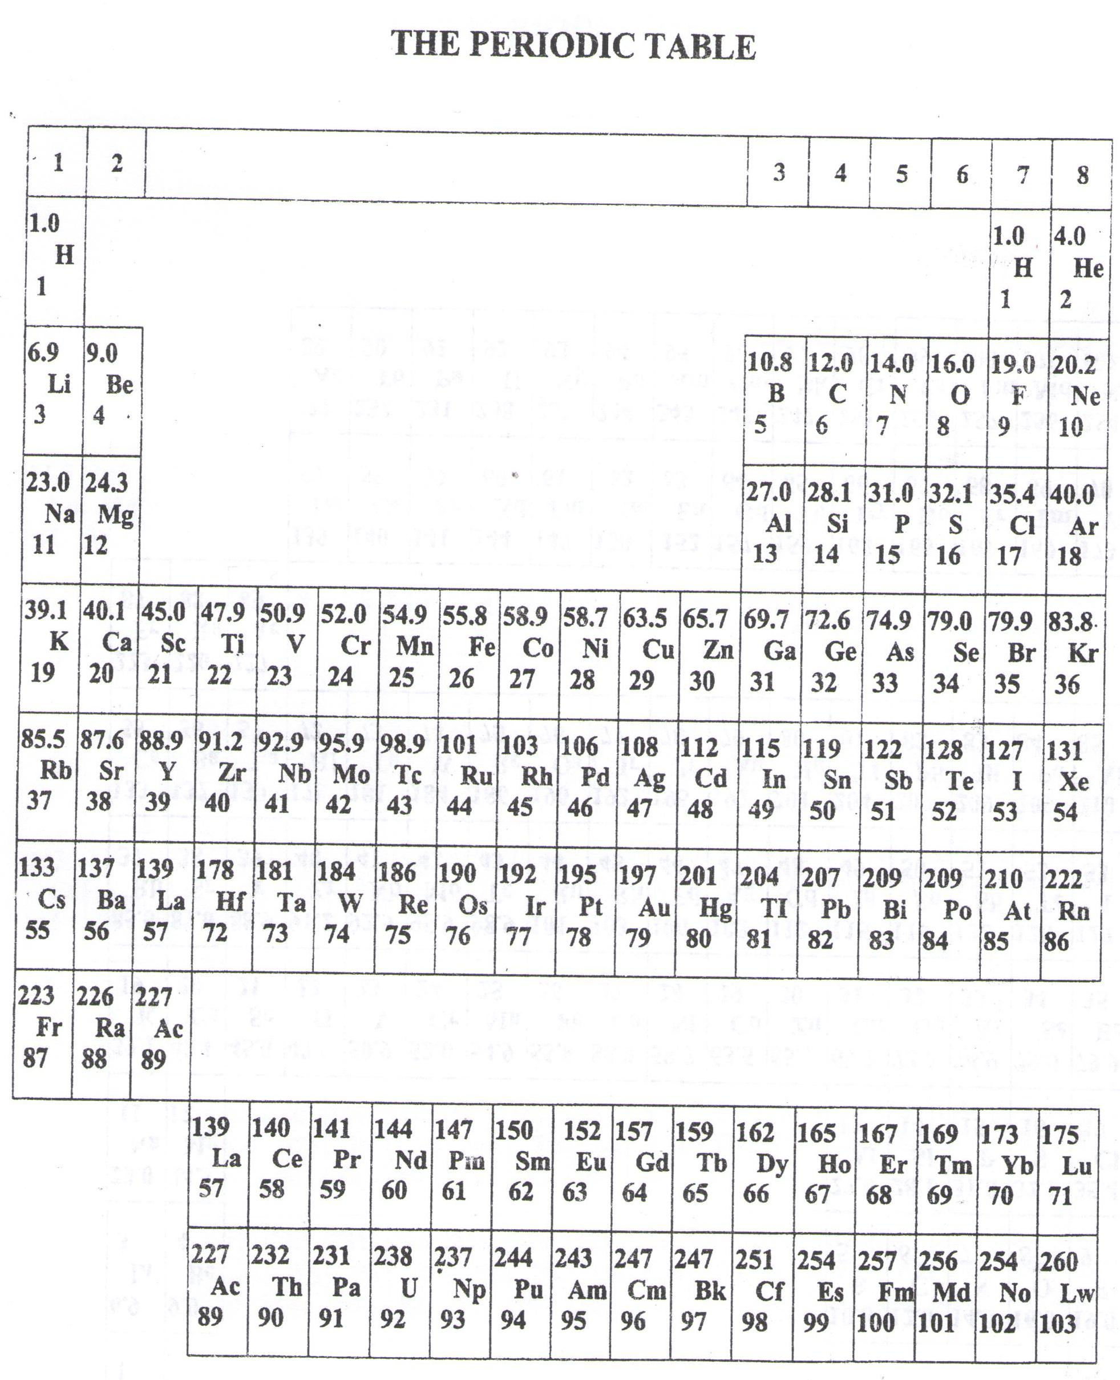

* ===END===

WELCOME TO SENIOR SIX, YEAR 2022

This is the last page of the printed paper, Page 23